**Object orienting programming homework**

I want to get the information from the user input into the HTML using the classes I built: Employee, Manager, Engineer, and Intern.

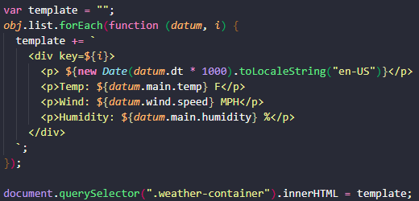

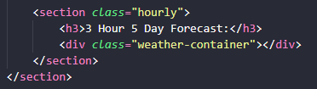

1. Create a template in the JS file.
2. Use a query selector to send it to a class in the HTML file.
3. Have a section in the HTML file that it can fall into.